User Management in Active Directory

Tasks

1. In Active Directory Users and Computers, create a new Organizational Unit (OU) called 'EventPlanners' to represent a team that manages college fests like those seen in BookMyShow.

ANS:

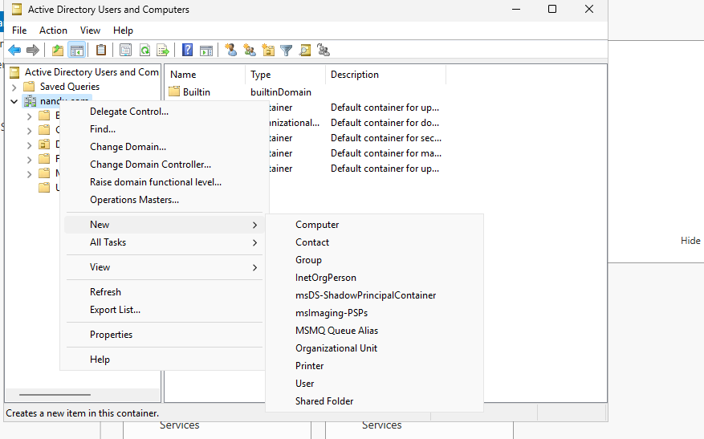

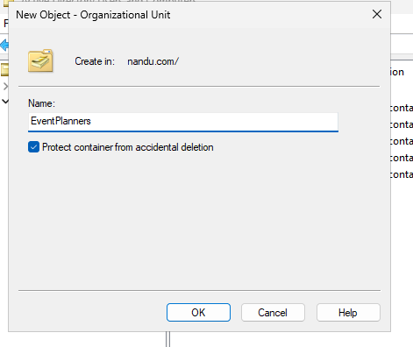

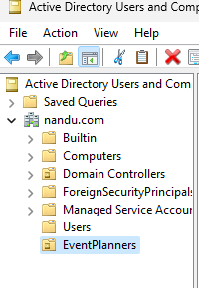

2. Add three user accounts to the 'EventPlanners' OU with usernames inspired by your favorite IPL cricket players (e.g., viratk, msdhoni, hardikp). Set a strong password for each and ensure 'User must change password at next logon' is enabled.

ANS:

On right click on OU (EvenetPlanner)

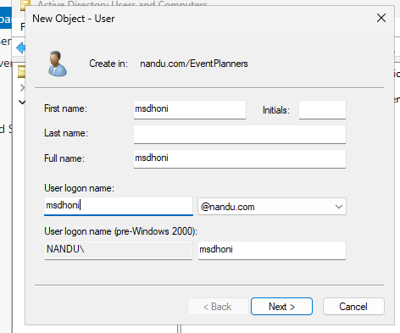

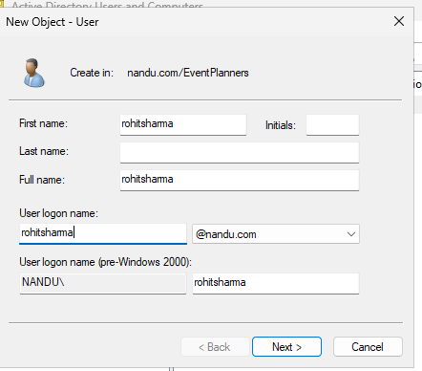

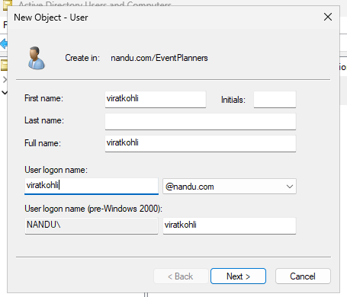

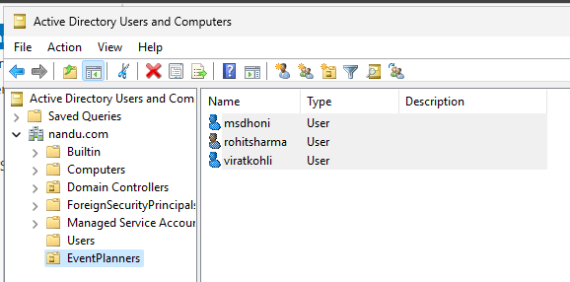

3. Create a security group named 'FestTicketManagers' inside the 'EventPlanners' OU. Add all three user accounts you created to this group.

ANS:

Create a group on EventPlanner OU

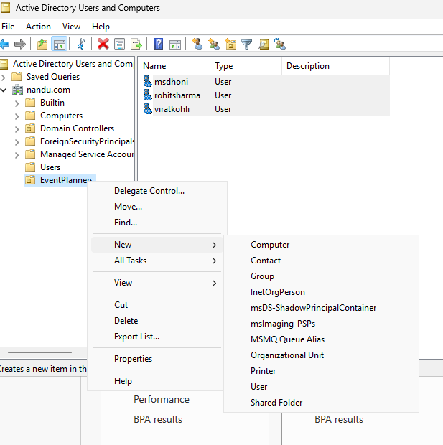

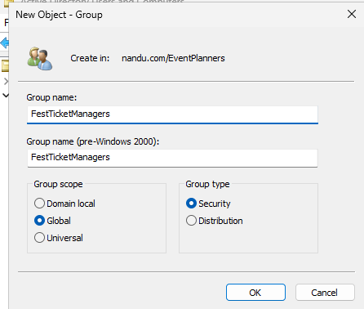
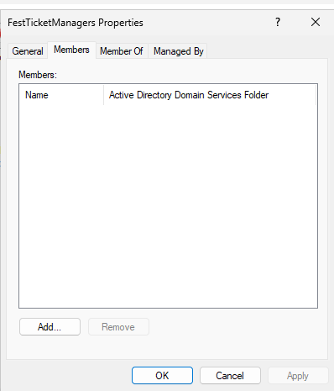

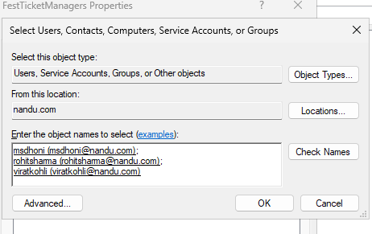

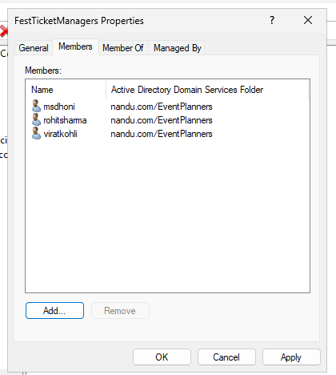

4. Rename one of your user accounts in the 'EventPlanners' OU to match your own first name and update their description field to 'Social Media Manager for College Fest'.

ANS:

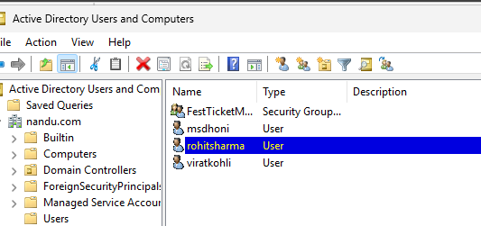

Rename ROHITSHARMA to ROHITS:



